**CHATBOT FOR HEALTH TRACKING**

Submitted to the Department of Computer Science and Engineering In partial fulfilment of the requirements

For the degree of Bachelor of Technology In

Computer Science and Engineering

By

**Shikhar Bajpai (2100140100090)**

**Shivam Gupta (2100140100092)**

**ShivamPatel (2100140100093)**

**Anshu Gangwar (2200140109003)**

Group No. 14

Guided By

**Mrs. Anu Saxena**



*Department of Computer Science and Engineering*

**Shri Ram MurtiSmarak College of Engineering & Technology, Bareilly Dr. A.P.J. Abdul Kalam Technical University, Lucknow**

December, 2023

**DECLARATION**

I hereby declare that this submission is my own and that, to be the best of my knowledge and belief, it contains no material previously published or written by another person nor material which to be substantial extent has been accepted for the award of any other degree or diploma of university or other institute of higher learning, except where due acknowledgement has been made in the text.

Signature………………………. Signature……………………….

Name: **Shikhar Bajpai** Name: **Shivam Gupta**

Roll No: **2100140100090** Roll No: **2100140100092**

Signature………………………. Signature……………………….

Name: **Shivam Patel** Name: **Anshu Gangwar**

Roll No: **2100140100093** Roll No: **2200140109003**

# 

**CERTIFICATE**

This is to certify that the Project Report entitled CHATBOT FOR HEALTH TRACKING which is submitted by SHIKHAR BAJPAI (2100140100090), SHIVAM GUPTA (2100140100092), SHIVAM PATEL (2100140100093), ANSHU GANGWAR (2200140109003) is a record of the candidates own work carried out by them under my supervision. The matter embodied is this work is original and has not been submitted for the award of any other work or degree.

Mr. Hiresh Kumar Gupta Ms. Anjali Arora Ms. Anu Saxena

**HOD(CSE) Project Incharge PROJECT GUIDE**

# ACKNOWLEDGEMENT

It gives us a great sense of pleasure to presents the report of the B. Tech Project undertaken during B. Tech 3nd year. We owe special debt of gratitude to assistant Professor **Ms. Anu Saxena** and project incharge **Ms. Anjali Arora**, Department of Computer Science & Engineering, S.R.M.S. C.E.T, Bareilly for his constant support and guidance throughout the course of our work. His sincerity, thoroughness and perseverance have been a constant source of inspiration for us. It is only his cognizant effort that our endeavors have seen light of the day.

We also take the opportunity to acknowledge the contribution of **Mr. Hiresh Kumar Gupta**, Head of Department of Computer Science & Engineering, S.R.M.S. CET, Bareilly for his full support and assistance during the development of the project.

We also do not like to miss the opportunity to acknowledge the contribution of all the faculty members of the department for their kind assistance and cooperation during the development of our project. Last but not the least, we acknowledge our friends for their contribution in the completion of the project.

Signature………………………. Signature……………………….

Name: **Shikhar Bajpai** Name: **Shivam Gupta**

Roll No: **2100140100090** Roll No: **2100140100092**

Signature………………………. Signature……………………….

Name: **Shivam Patel** Name: **Anshu Gangwar**

Roll No: **2100140100093** Roll No: **2200140109003**

# ABSTRACT

The "HealthBot" project introduces a revolutionary approach to individualized health and wellness management, combining the power of artificial intelligence and natural language processing to provide tailored recommendations on exercise, nutrition, and ongoing health monitoring. In an era marked by the importance of personal well-being, HealthBot offers a personalized and data-driven solution for users seeking guidance on their unique health and lifestyle needs.

Key Features of HealthBot:

1. Personalized Health Assessment: HealthBot begins by conducting a thorough evaluation of each user's health profile, taking into account factors such as age, gender, existing medical conditions, fitness levels, and personal health goals. This information forms the basis for the creation of a highly customized health plan.
2. Tailored Exercise Regimens: Leveraging user-specific health data, HealthBot generates personalized exercise routines that adapt over time to ensure they remain challenging yet achievable. The Chatbot provides guidance on exercise type, duration, and intensity, promoting physical fitness while minimizing the risk of injury.
3. Continuous Health Monitoring: Utilizing data from wearable devices and integrated health apps, HealthBot continually tracks users' health metrics, such as heart rate, sleep patterns, and weight fluctuations. It alerts users to significant changes and provides actionable insights to maintain or improve health.
4. Real-time Interaction: HealthBot is designed to engage users in a dynamic and interactive conversation, providing instant responses to health-related queries and concerns. Users can seek guidance on everything from symptom interpretation to medication reminders.

HealthBot stands at the forefront of personalized health management, harnessing the power of artificial intelligence to deliver tailored solutions for users' unique well-being needs. It empowers users to take control of their health journey and make informed choices, ultimately fostering a healthier and happier lifestyle. In an age where personalized health guidance is essential, HealthBot emerges as a vital companion on the path to well-being.

# TABLE OF CONTENT

ACKNOWLEDGEMENT 4

ABSTRACT 5

TABLE OF CONTENT 6

LIST OF FIGURES 7

1 INTRODUCTION 6

1.1 PROBLEM STATEMENT 6

1.1.1 Purpose of the Project 7

1.1.2 Scope of the Project 7

2. LITERATURE REVIEW 8

3. METHODOLOGY 10

4 SYSTEM DESIGN 11

5 TECHNOLOGY USED 12

6 REQUIREMENTS 12

6.1 Hardware Requirements 12

6.2 Software Requirements 12

REFERENCES 16

# LIST OF FIGURES

Figure 1: System Design 11

Figure 2: System Architecture and Knowledge Model 11

# INTRODUCTION

In an age where the pursuit of health and wellness is of paramount importance, the "HealthBot" project emerges as a groundbreaking solution to address the growing need for personalized, accessible, and data-driven health management. Health and well-being are deeply personal, influenced by an individual's unique characteristics, goals, and circumstances. As such, a one-size-fits-all approach to health guidance falls short of effectively supporting the diverse needs of individuals seeking to lead healthier lives.

The "HealthBot" project seeks to revolutionize the way people approach their health and wellness by leveraging the capabilities of artificial intelligence and natural language processing. With an unwavering commitment to personalized health management, this innovative chatbot application offers a comprehensive suite of features that encompass personalized exercise regimens, tailored nutritional guidance, continuous health monitoring, and real-time interaction. It is designed to empower users to make informed choices regarding their health and to support them throughout their journey towards well-being.

In this synopsis, we delve into the core features and functionalities of HealthBot, highlighting its ability to offer users a truly personalized health and wellness experience. The project's foundation is built on a profound understanding of the need for customized health solutions and a dedication to ensuring that users receive not only practical advice but also unwavering support on their quest for a healthier and happier life.

## PROBLEM STATEMENT

In the modern era, with its heightened emphasis on health and well-being, a significant problem arises in the form of a one-size-fits-all approach to health management. Traditional health and wellness resources often fail to cater to the diverse and evolving needs of individuals. Many individuals are left without a comprehensive, personalized solution to address their unique health and lifestyle goals. This problem is compounded by the lack of accessible and user-friendly platforms that offer continuous support and guidance, resulting in frustration, misinformation, and the potential for health issues to remain unaddressed.

Additionally, in a world that increasingly relies on technology, there is a demand for innovative, AI-driven tools that can provide individualized and data-driven health recommendations. Current health management practices often lack the agility and real-time feedback needed to adapt to changing health conditions and goals.

The "HealthBot" project, as outlined in this synopsis, seeks to tackle these issues head-on by introducing a groundbreaking approach to health management. By leveraging artificial intelligence and natural language processing, the project aims to provide users with personalized, interactive, and continuous support for their health and wellness goals, effectively addressing the problems of inadequate personalization, limited accessibility, and insufficient real-time feedback in existing health management systems. Through its innovative features and user-centric design, "HealthBot" endeavours to offer a practical and tailored solution to empower individuals on their journey toward better health and well-being.

## Purpose of the Project

The "HealthBot" project's primary purpose is to provide a groundbreaking and user-centric solution for personalized health and wellness management. It aims to:

* + - 1. Tailor recommendations based on individual health profiles.
      2. Offer accessible and continuous support through user-friendly digital platforms.
      3. Empower users with data-driven insights for informed decision-making.
      4. Stay at the forefront of health management innovation, adapting to changing trends and individual needs.

## Scope of the Project

The "HealthBot" project involves a structured approach with phases like research, design, development, testing, launch, and continuous improvement. It focuses on user research, AI technology, and user-friendly design.

The project aims to create an AI-driven chatbot for personalized health guidance, featuring user profiles, AI-generated health recommendations, an interactive interface, privacy measures, and iterative development. It aims to provide a holistic solution for health and wellness management with potential for expansion and adaptation.

# LITERATURE REVIEW

* 1. kBot: Knowledge-enabled Personalized Chatbot for Asthma Self-Management

The research study [3] is a chatbot that is designed for a pediatric patient who is suffering from asthma whose age limit is between ages 8-15. So this chatbot acts as a knowledge-enabled chatbot system that can be considered as a personalized health application. Following the concept of the chatbots, this kBot is well concerned about the patients’ history of data generating meaningful responses to each person separately using the help of the in-depth domain Knowledge. Monitoring the patient’s daily medication adherence and tracking the environmental data and health signals can be considered as the core-functionalities of kBot. The front end of this application comes as an android application and the backend as a web-based server application for data handling procedures. The special feature of kBot is that it supports both voice and text which increases the interaction between both user and client. This kBot is a Python web application that serves as well as instantiated more no of kBot clients. The functionalities such as database operation, ability in pushing notifications, email alerts file log, and weather report are conducted by the server layer. Also, Google Android applications are considered as the clients of this system. Also, NLP (Natural Language Processing and ML(Machine Learning ) bases Google’s well-known developer platform,” Dialog Flow used for both dialogue Parsing and processing. With the help of these technologies, kBot reveals that there is a considerable acceptance of this kBot as an ‘asthma self-management ‘’system among the experts who are in a domain and non-domain areas.

* 1. Use of the Chatbot “Vivibot” to Deliver Positive Psychology Skills and Promote Well-Being Among Young People After Cancer Treatment: Randomized Controlled Feasibility Trial

Also, Vivibot [6] is a chatbot built to reduce the anxiety and depression of people. It uses a decision tree structure to deliver pre-written and automatically delivered materials via online medium to the users. It is a non-artificial intelligence-based content-delivery system. Also, Vivibot supports the psychological health of the younger generation who are suffering from cancer in vulnerable situations they face during their life after the diagonalization of the disease.

* 1. Text-based Healthcare Chatbots Supporting Patient and Health Professional Teams: Preliminary Results of a Randomized Controlled Trial on Childhood Obesity

Another research study [7]brings a text-based chatbot(THCB) that is mainly designed to focus on a set of visual cues(limited in number) and linguistic cues. This THCB supports both young patients with obesity and health professionals who are responsible for these teenagers’ health. According to the research analysis, it is found that the scalability of the chatbot application is very high since there have been over 99.5% conversational turns. Also, the perspectives about the enjoyment and the interaction with this THCB are positive. Also, the system can be designed with specific rules to push notifications mostly like healthcare professionals automatically. Hence, It is not an essential thing to monitor the conversational turns between both THCB and patients by health professionals. The system has consisted of a chat channel that provides predefined options similar to the Traditional chatting systems but with more efficient chat interactions. Also, there is a second chat channel to communicate like iMessage or Whatsapp. Also, this channel will help in situations where cannot be automatically supported by the patients using THCB.further the health professional can use this channel. if they want to interact with patients by giving motivational advice and asking to do ad-hoc tasks. So, THCB mainly targets linguistic cues and a limited no of visual cues to provide the best health care support.

* 1. Chatbots to Promote Physical Activity and a Healthy Diet: Viewpoint

This study [8] proposes a theoretical framework to develop ethical AI-powered chatbots to predict behavior changes. This study mainly focuses on improving physical activities and dieting practices. Similar to the other chatbots, the study also focuses on building the natural language conversation feature. So, this feature directly helps to exchange the relevant information between the human being and the chatbot flexibly.

.

# METHODOLOGY

### API Integration and Data Gathering:

* 1. Identify and integrate relevant health and fitness APIs to access data such as exercise routines, nutritional information, and real-time health monitoring.
  2. Set up data pipelines for collecting user health metrics from wearable devices and health apps.

### User Interface Design with React:

* 1. Design user interfaces for web and mobile platforms using React components, ensuring a responsive and intuitive user experience.
  2. Implement user profiles and dashboards for viewing health data and recommendations.

### Development and Backend Integration:

* + 1. Develop the backend using suitable technologies (e.g., Node.js or Python) to process data from APIs and handle user requests.
    2. Integrate API data into the chatbot's recommendations and user profiles within the React frontend.

### Launch and Deployment:

* + 1. Deploy the React-based chatbot on web and mobile platforms, ensuring it works seamlessly with the integrated APIs.
    2. Execute marketing strategies to promote the chatbot's accessibility and user benefits.

### Continuous Improvement and Expansion:

* + 1. Continuously update and improve the React-based user interfaces based on user feedback.
    2. Enhance the chatbot's capabilities by integrating new health-related APIs and services.
    3. Engage users with informative content and support resources via the React- based platform.

This revised methodology takes advantage of API integration and React to provide users with a dynamic, responsive, and personalized health and wellness chatbot. It emphasizes the importance of seamless data integration and responsive user interfaces to offer an enhanced user experience. The methodology remains iterative, allowing for ongoing improvements and adaptability to changing health trends and user needs.

# SYSTEM DESIGN

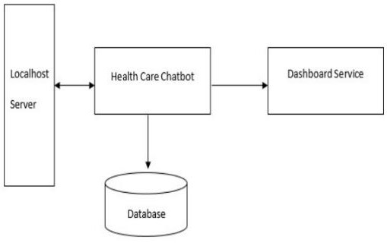

*Figure 1: System Design*

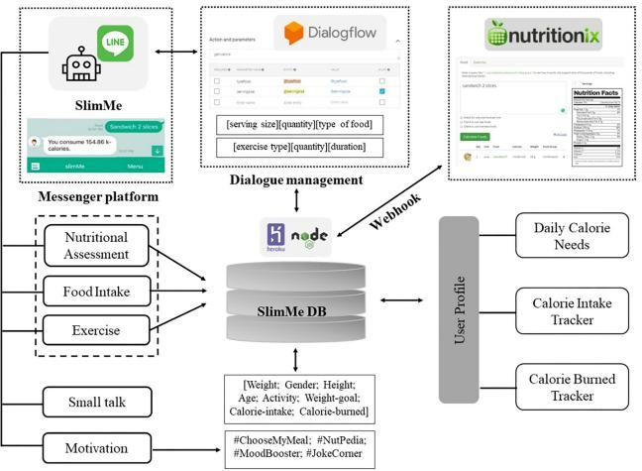

*Figure 2: System Architecture and Knowledge Model*

# TECHNOLOGY USED

Technologies required for making this project are as follows: -

* HTML
* CSS
* JavaScript
* Python
* MySQL Databases
* React framework

# REQUIREMENTS

There are some hardware and software requirement for making this project as follows:

## Hardware Requirements

* + - Processor Type: Pentium IV or above for optimum performance.
    - System RAM: 4.00GB or above.
    - Storage Required: 32GB or above.
    - Operating System: Windows 10, Linux.

## Software Requirements

* + - Visual Studio Code (or VS Code) as Code editor
    - HTML, CSS, & JAVASCRIPT
    - Local Hosting Server
    - Web browser (Firefox, Chromium, Safari etc.)

**APPENDIX**

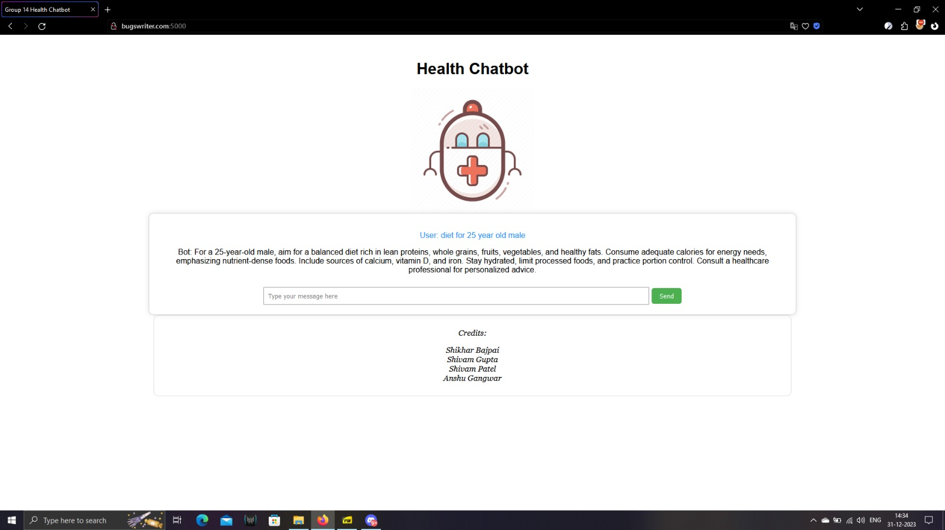

Figure 1 Diet for 25 year male

Figure 2 Chest exercise

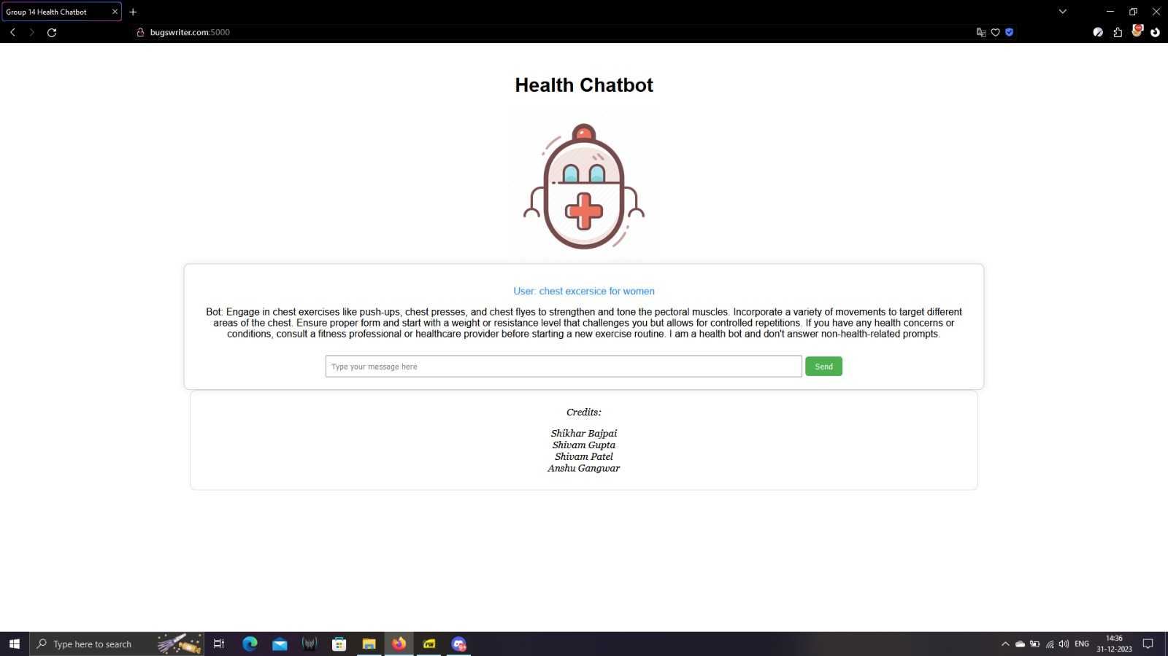

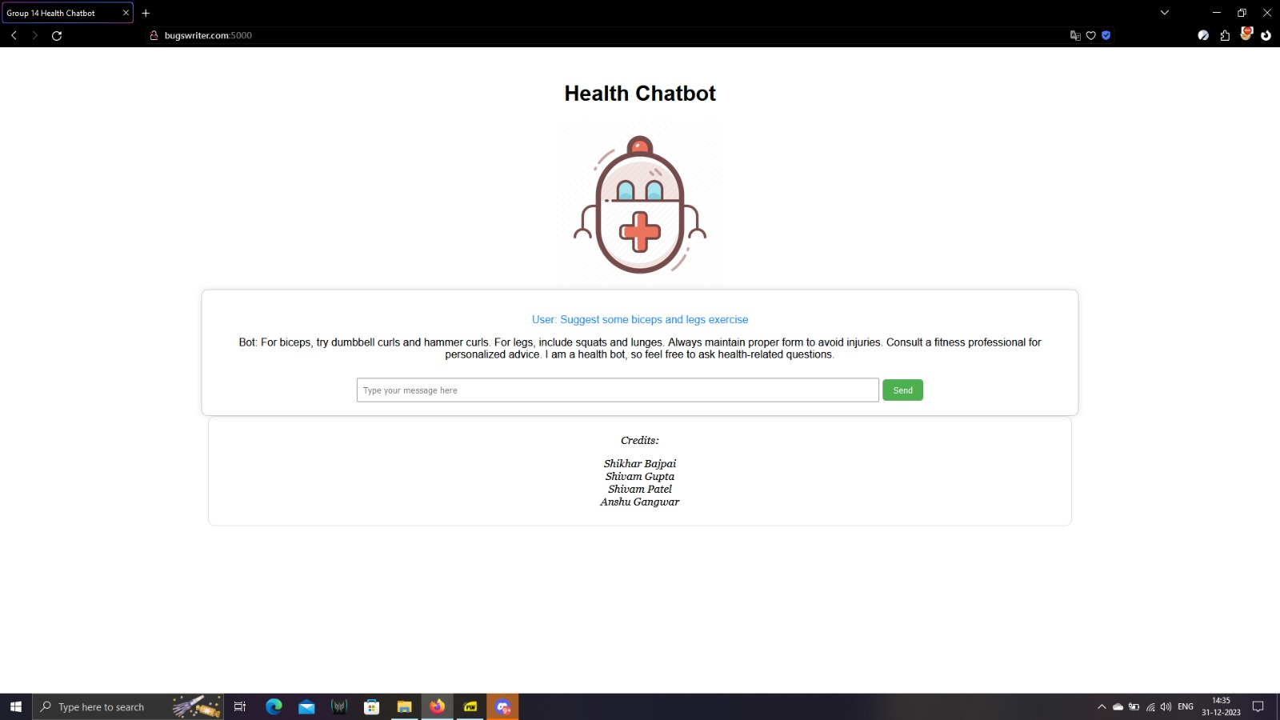

Figure 3 Suggest some biceps and legs exercise

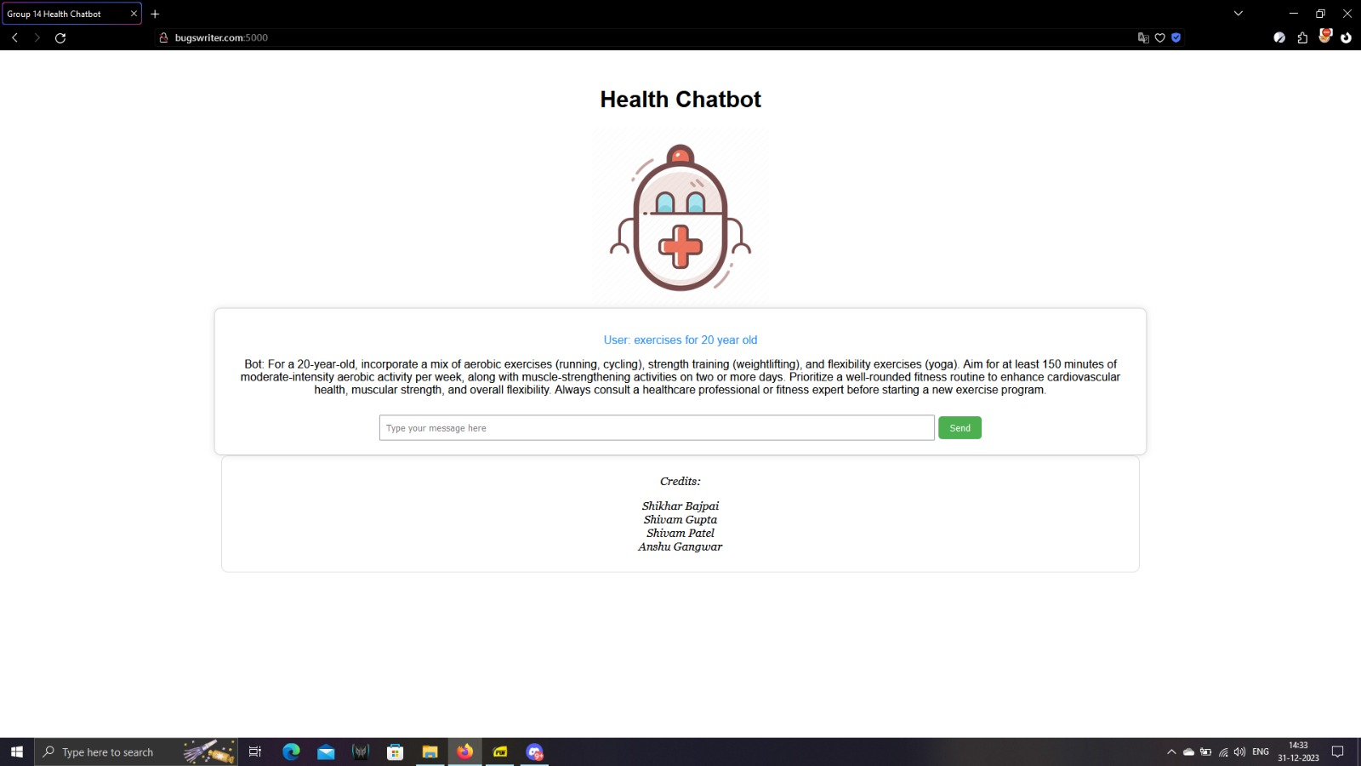

Figure 4 Exercise for 20 year old

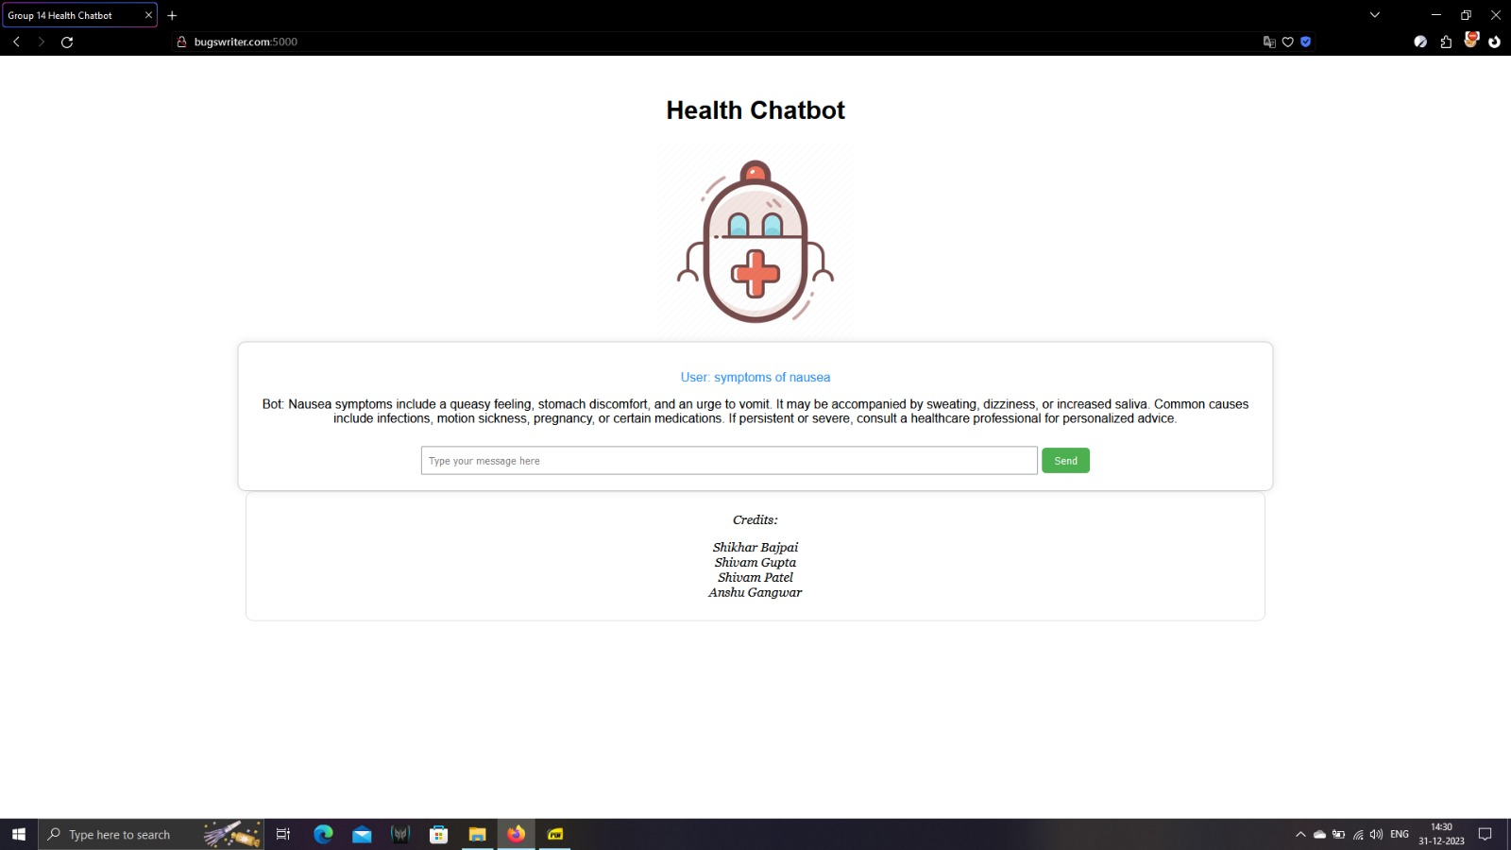

Figure 5 Symptoms for nausea

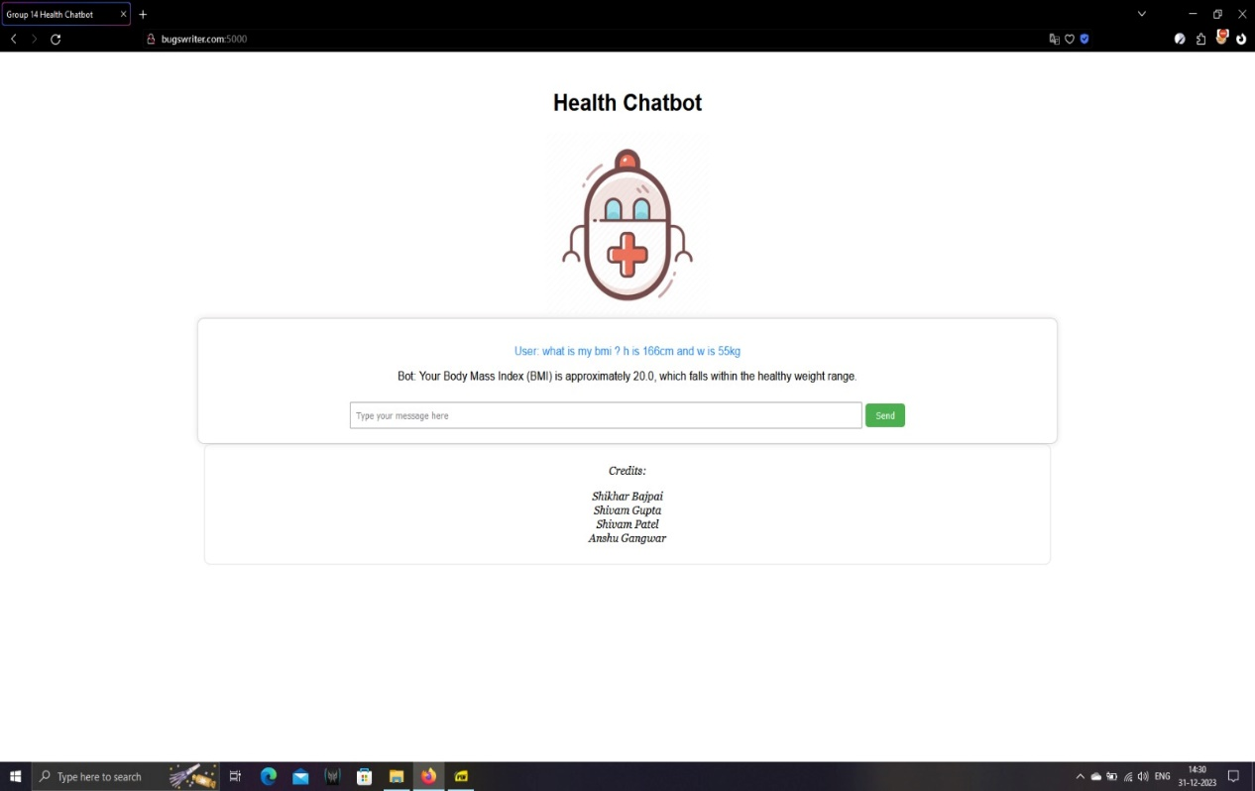

Figure 6 BMI calculation using Chatbot

# REFERENCES

1. Pew Research Center. Available from: https://[www.pewresearch.org/fact-](http://www.pewresearch.org/fact-)

tank/2017/12/12/nearly- half- of- americans- use- digital- voice-

assistants- mostly- on- their- smartphones/.

1. Nutritionix. (2017). Available online at: https://[www.nutritionix.com/ (May30, 2022)](http://www.nutritionix.com/(May30%2C2022))
2. G. Cameron et al., “Towards a chatbot for digital counseling,” HCI 2017 Digit. Make Believe - Proc. 31st Int. BCS Hum. Comput. Interact. Conf. HCI 2017, vol. 2017-July,

pp. 1–7, 2017, doi:10.14236/ewic/HCI2017.24...

1. World Health Organization. Obesity Preventing and Managing the GlobalEpidemic. Available online at:https://apps.who.int/iris/handle/10665/42330
2. World Health Organization. Obesity and Overweight. (2021). Availableonline at: https://[www.who.int/news-room/fact-sheets/detail/obesity-and-overweight](http://www.who.int/news-room/fact-sheets/detail/obesity-and-overweight)
3. A. Ghandeharioun, D. McDuff, M. Czerwinski and K. Rowan, “EMMA: An Emotion- Aware Wellbeing Chatbot,” 2019 8th Int. Conf. Affect. Comput. Intell. Interact. ACII 2019, pp. 15–21, 2019, doi: 10.1109/ACII.2019.8925455.
4. S. Greer, D. Ramo, Y. J. Chang, M. Fu, J. Moskowitz, and J. Haritatos, “Use of the chatbot ‘vivibot’ to deliver positive psychology skills and promote well-being among young people after cancer treatment: Randomized controlled feasibility trial,” JMIR mHealth uHealth, vol. 7, no. 10, pp. 1–13, 2019, doi: 10.2196/15018.
5. S. M. Jungmann, T. Klan, S. Kuhn, and F. Jungmann, “Accuracy of a chatbot (Ada) in the diagnosis of mental disorders: comparative case study with lay and expert users,” JMIR Form. Res., vol. 3, no. 4, Oct. 2019, doi: 10.2196/13863.
6. "Real World Smart Chatbot for Customer Careusing a Software as a Service (SaaS) Architecture“Godson Michael D’silva1”, Sanket Thakare2, Shraddha More. Available:https://[www.docme.ru/doc/2207164/i-smac.2017.8058261](http://www.docme.ru/doc/2207164/i-smac.2017.8058261)

## CHATBOT FOR HEALTH TRACKING

By

## Group no. 14

Signature………………………. Signature……………………….

Name: **Shikhar Bajpai** Name: **Shivam Gupta**

Roll No: **2100140100090** Roll No: **2100140100092**

Signature………………………. Signature……………………….

Name: **Shivam Patel** Name: **Anshu Gangwar**

Roll No: **2100140100093** Roll No: **2200140109003**

### Mr. Hiresh Gupta Ms. Anjali Arora Mrs. Anu Saxena

**HOD (CSE) PROJECT INCHARGE PROJECT GUIDE**

**……………………….. ……………………….. ………………………..**



## Department of Computer Science and Engineering

**Shri Ram Murti Smarak College of Engineering & Technology, Bareilly Dr. APJ Abdul Kalam Technical University, Lucknow**

November, 2023